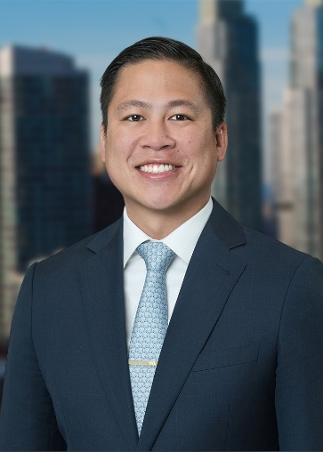  Education  - Rutgers Law School, J.D.  - University of Florida, B.S.,  Bar Admissions  - New York  - New Jersey  Court Admissions  - U.S. District Court for the District of New Jersey  - U.S. District Court for the Southern District of New York  - U.S. District Court for the Eastern District of New York | Nicholas S. Pradaxay Associate Office: New York T: 310.274.7100 F: 310.275.5697 npradaxay@ellisgeorge.comm  Nicholas S. Pradaxay is an Associate in Ellis George’s New York office.  His substantive practice includes handling class action defense, contractual disputes, labor and employment, business dissolution and stockholder derivative suits, trade secret misappropriation, copyright infringement, premises liability, commercial real estate, foreclosure, secured transactions, mass tort liability, and corporate malfeasance matters.  After law school, Nick also clerked with the New Jersey Superior Court, Appellate Division, where he researched, drafted, and edited judicial opinions and complex bench memoranda for appellate cases arising out of orders by the civil, criminal, family, and administrative parts.  Nicholas earned his J.D. from Rutgers Law School in 2018 where he was he was a Business Editor on Law Review.

